# DAD 220 Cardinality and Targeted Data Template

Replace the bracketed text in this template with your screenshots and responses. Then submit it to the Module Four Lab for submission, grading, and feedback. Screenshots should be sized to approximately one quarter of a page. Written responses should be in complete sentences. Rename this document by adding your last name to the file name before you submit.

1. **1.** **Retrieve employee tuples and identify the number of employees** in San Francisco and New York.

commands: select firstName, lastName, jobTitle, offices.city from employees inner join offices on employees.officeCode = offices.officeCode where state = ‘CA’;

select firstName, lastName, jobTitle, offices.city from employees inner join offices on employees.officeCode = offices.officeCode where state = ‘NY’;

There are 8 employees in San Francisco and New York.

1. **2.** **Retrieve order details** for orderNumber 10330, 10338, and 10194 and **identify** what **type of cardinality** this represents in the entity relationship model.

Command: select * from orderDetails where orderNumber = 10330 or orderNumber = 10338 or orderNumber = 10194;

In the relationship between orderdetails and products the min-max is 1-1.

In the relationship between orderdetails and orders the min-max is 1-1.

* 1. Orderdetails also has a composite primary key made of the primary keys of both of these tables because it is dependent on both of them.
  2. The relationship between orders and products is one-to-many because for one order you can have many products.

1. **3.** **Delete records** from the payments table where the customer number equals 103.
   1. 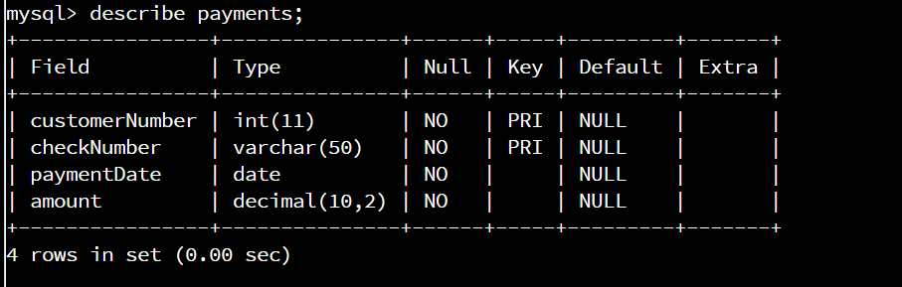Describe payments;
   2. A screenshot of a computer

      Description automatically generated with medium confidenceSelect * from payments where customerNumber = 103;
   3. Text

      Description automatically generated delete from payments where customerNumber = 103;
   4. Select * from payments where customerNumber = 103;
2. **4.** **Retrieve customer records** for sales representative Barry Jones and **identify** if the **relationships** are one-to-one or one-to-many**.**

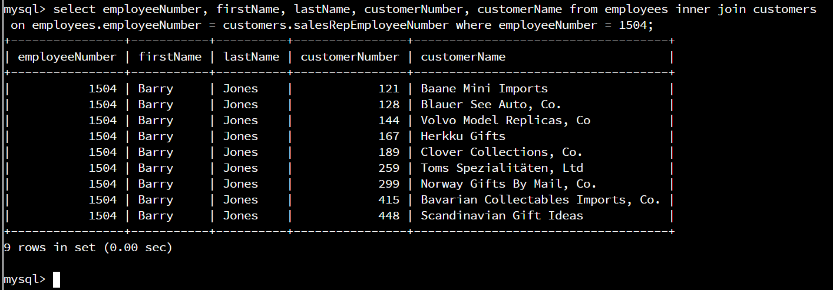

select employeeNumber, firstName, lastName, customerNumber, customerName from employees inner join customers on employees.employeeNumber = customers.salesRepEmployeeNumber where employeeNumber = 1504;

The relationships between Barry Jones and customers is one-to-many.

1. **5.** **Retrieve records** for customers who reside in Massachusetts and **identify** **their sales rep and the relationship of entities**. Identify if these entities demonstrate one-to-one or many-to-many relationships.

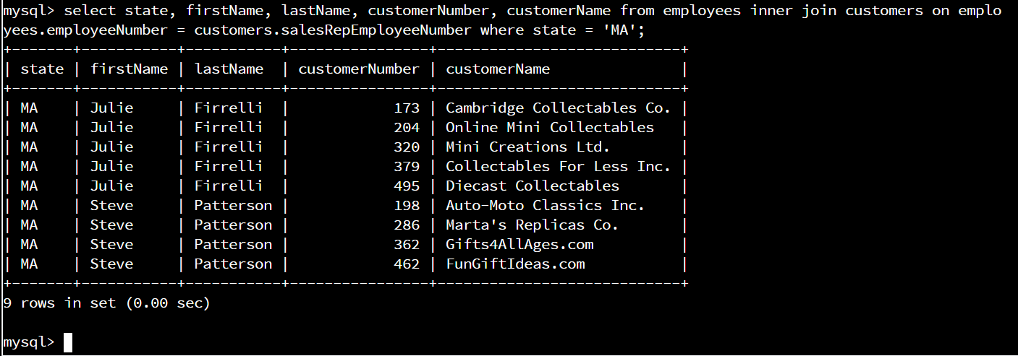

Select state, firstName, lastName, customerNumber, customerName from employees inner join customers on employees.employeeNumber = customers.salesRepEmployeeNumber where state = ‘MA’;

The relationship between Massachusetts and sales reps is many-to-many.

1. **6.** **Add one customer record** with your last name using an INSERT statement. You may use the name of a celebrity or fictional character if you don’t use your own name.



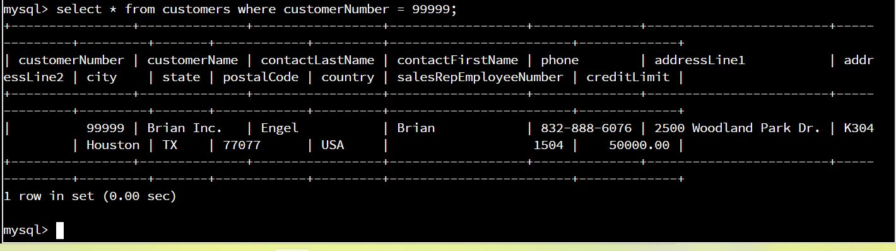

Insert into customers values (99999, ‘Brian Inc.’, ‘Engel’, ‘Brian’, ‘832-888-6076', ‘2500 Woodland Park Dr.’, ‘K304’, ‘Houston’, ‘TX’, ‘77077’, ‘USA’, 1504, 50000.00);

Select * from customers where customerNumber = 99999;

1. **7.** **Reflection**
   1. **Define how cardinality is applied** to the databases you’ve been working with and why different numbers of records returned from the different offices.
      1. Offices have many employees which would be one-to-many and employees have many customers which would be one-to-many as well. This would lead to the select statements we used having very different results.
   2. **Compare and contrast** the different **queries** you ran and how cardinality applies to them.
      1. The first set of inner joins we did just identified the employees at the San Fransisco and New York offices. Those relationships are one-to-many. The second select statement pulled specific order numbers. The result showed us that it was a one-to-many relationship again because there where many products for every order. The next inner join was between a salesperson and their customers and once again it was a one-to-many relationship. The last inner join was different than the others. We joined customers in MA and employees in MA. There were several of each so the relationship was many-to-many.
   3. **Describe two** of the crucial **benefits** **of cardinality** in this type of database.
      1. One of the benefits of cardinality in this database because it makes it easy to query relevant information easily. Another benefit is just by looking at the select results you can see the how the tree of information is formed, making it easier to figure out what you need to input to search for something specific.